Final Project Report
Student: Omar Moldir
Group: se-2434
Project Title: Devine Real Estate Platform
Date: November 2025

1. Introduction
This report describes my final web development project — Online Real Estate Platform.
The main purpose of the project was to design and build a multi-page, fully interactive, and responsive website using HTML, CSS, Bootstrap, JavaScript, and jQuery.
The platform simulates a real estate marketplace where users can explore property listings, view details, and personalize their browsing experience with theme settings and saved favorites.

2. Project Objective
The objectives were to:
- Create a website consisting of at least five interconnected pages.
- Maintain a consistent and professional design across all pages.
- Implement Local Storage to save user preferences.
- Add a Dark/Light Mode toggle for improved user experience.
- Ensure responsiveness for mobile, tablet, and desktop devices.

3. Website Structure
The project contains the following main pages:
- Home Page – introduction and navigation menu.
- Properties Page – shows property listings in a responsive grid.
- Property Details Page – dynamically displays property information.
- Favorites Page – allows users to view saved properties using Local Storage.
- Contact Page – includes a feedback form with JavaScript validation.
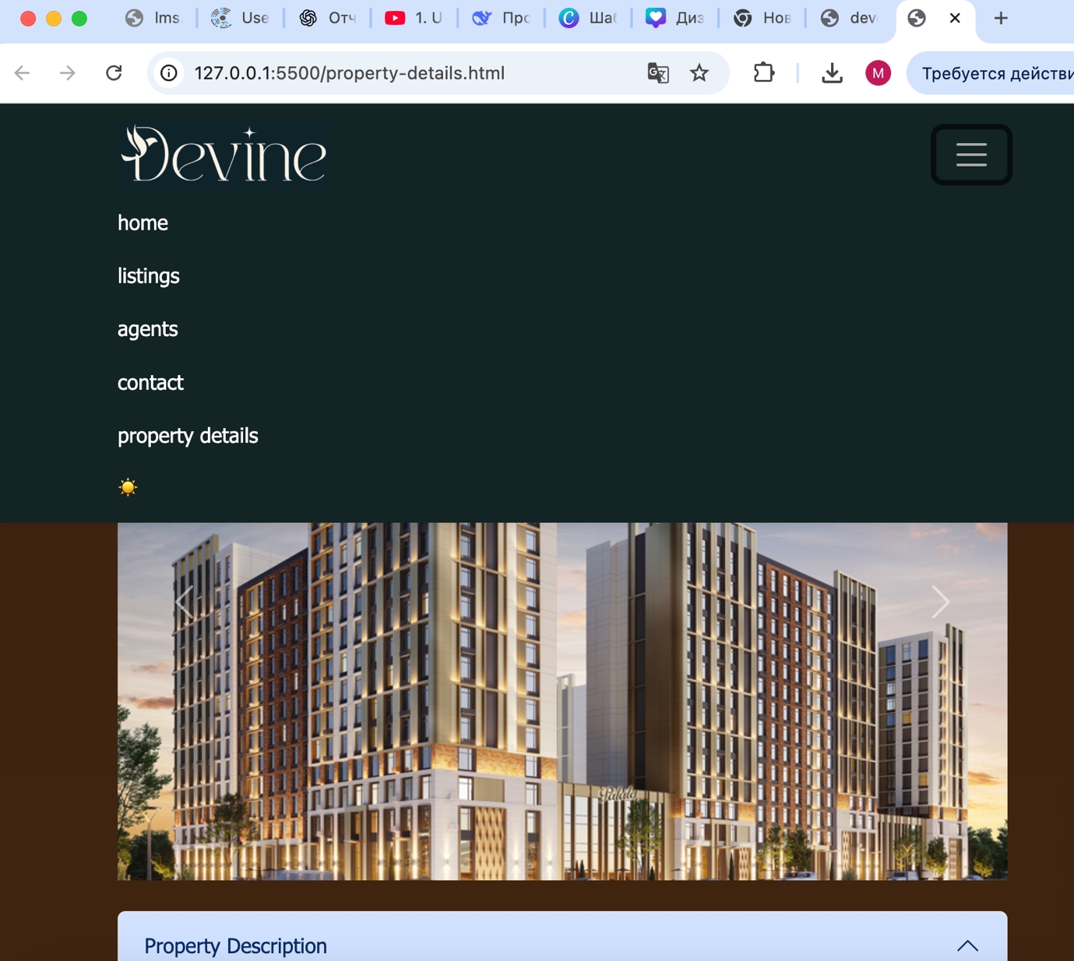

4. Technologies Used
Technology | Purpose
HTML5 | Structure and layout
CSS3 | Styling and customization
Bootstrap 5 | Responsive grid and layout system
JavaScript (ES6) | Interactivity and DOM manipulation
jQuery | Simplified scripting and event handling
Local Storage | Store and retrieve user data (favorites, theme)
Dark/Light Mode | JavaScript toggle with stored user preference
GitHub Pages / Netlify | Project deployment

5. Advanced Features
1. Local Storage
Local Storage was implemented to save user data such as:
- Favorite properties
- Selected theme (dark or light mode)
When the user adds a property to favorites or changes the theme, the data is saved in Local Storage and persists even after reloading or closing the browser.
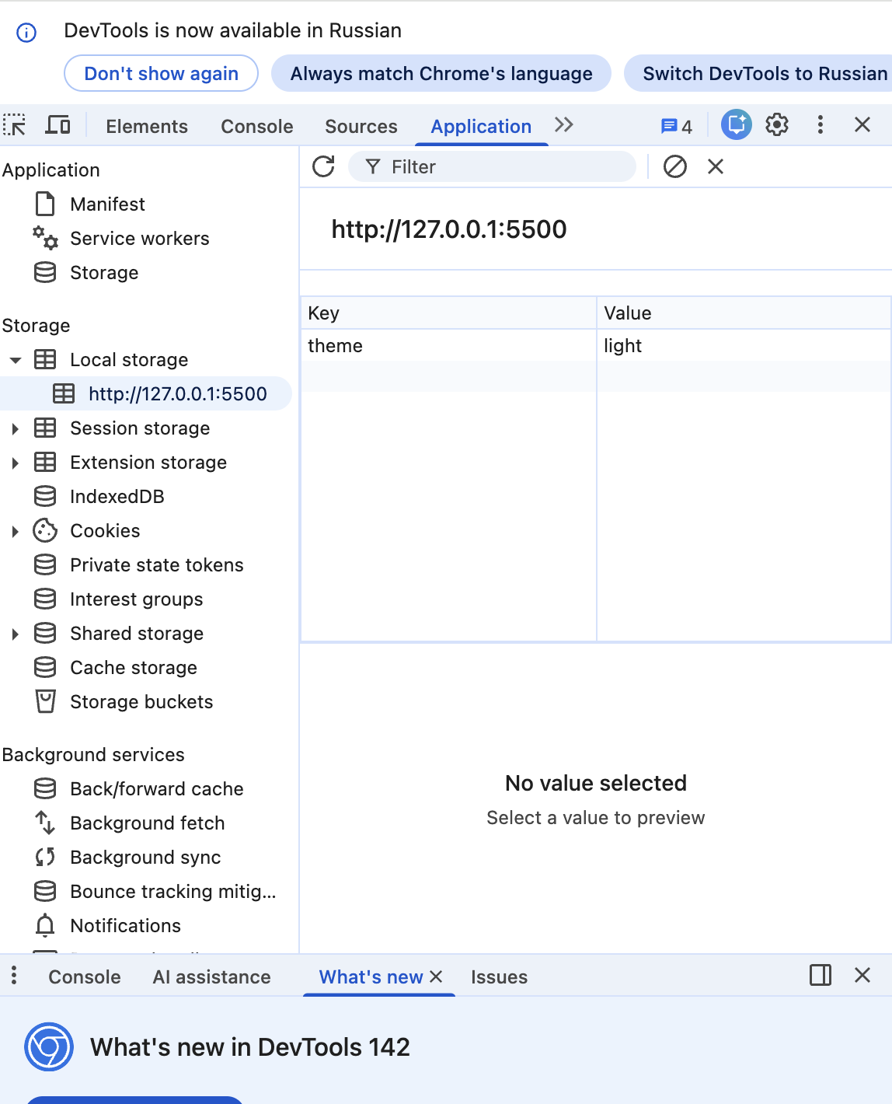
2. Dark/Light Mode Toggle
The website includes a JavaScript-based theme switcher:
- A toggle button lets users switch between light and dark modes.
- The user’s preference is stored in Local Storage and automatically applied when revisiting the site.

6. Design & Responsiveness
- The website uses a Bootstrap grid system for flexible layouts.
- Custom CSS variables were used to adjust colors in dark and light themes.
- The design is fully responsive and adapts to all screen sizes.
- 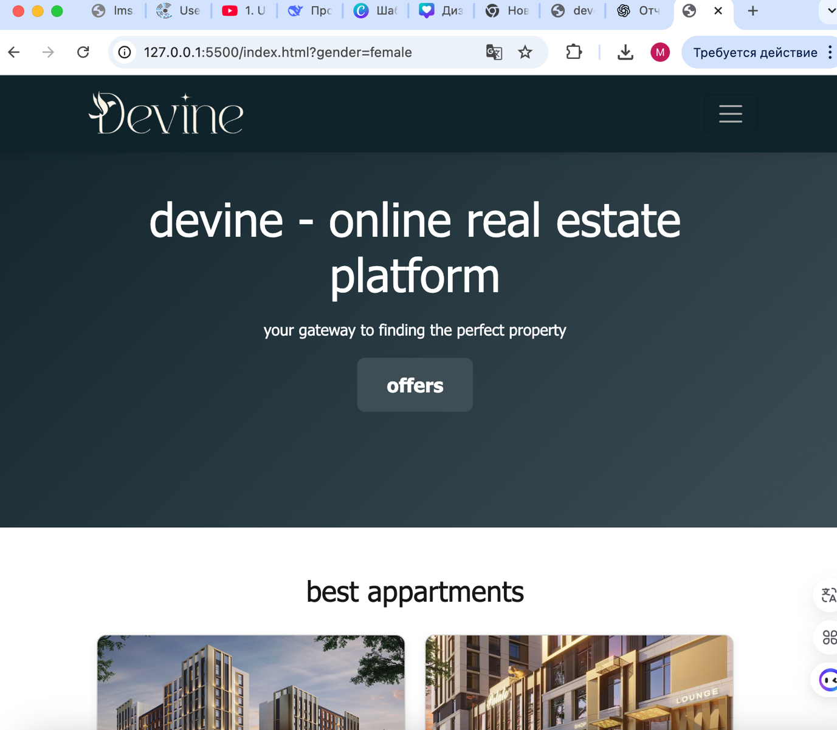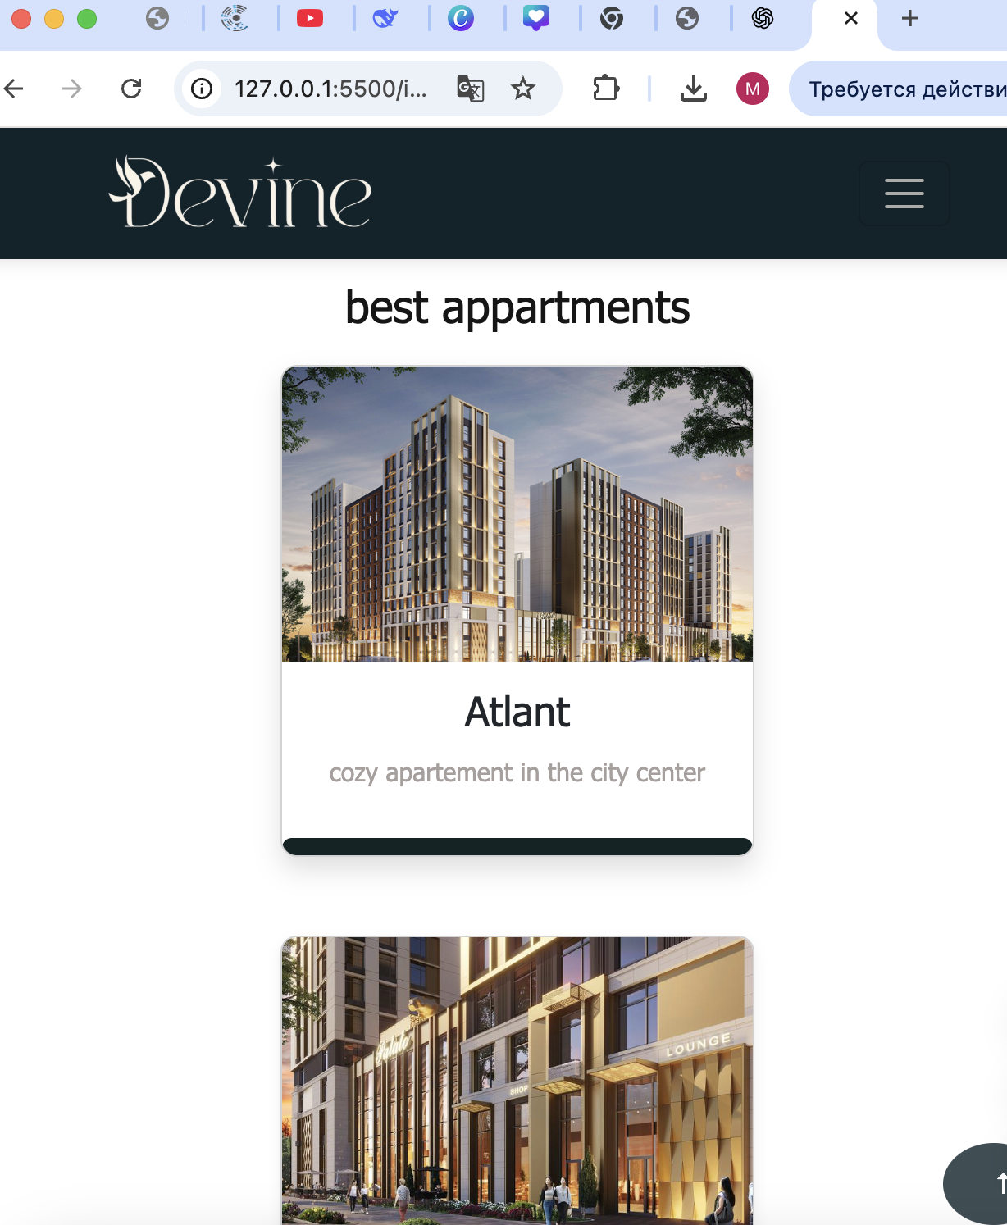

7. Challenges & Solutions
Challenge | Solution
Maintaining consistent theme across all pages | Used Local Storage to store the theme preference globally
Making layout fully responsive | Used Bootstrap grid and flexbox for adaptable design
Saving user data persistently | Implemented localStorage.setItem() and getItem() for favorites and theme

8. Conclusion
This project allowed me to gain hands-on experience with interactive front-end development.
I successfully implemented Local Storage and Dark/Light Mode — two advanced features that improve user experience and demonstrate real-world application of JavaScript.
The project strengthened my understanding of responsive design, dynamic interaction, and data persistence in web applications.

